**Connecting with External data bases:**

**External Data base Connection:**

**pgadmin4- IDE**

**Steps to Connect External Data base:**

**Step1. Create Physical DB Using DB Environment & Add Required privileges**

**Step2. Create Physical table along with columns & Add Required privileges**

**Step3. Make Connection b/w PRPC & Data base by creating Database Rule**

**Step4. Create a Data Type & Properties to map to above table & Add Source**

**Step5. For Class & Table mapping create Database table rule**

**Step6. Create a Connect SQL Rule & write required Statements**

**Step7. Create an Activity & Use RDB Methods to Execute above queries**

**==========**

**Step1. Create Physical DB Using DB Environment & Add Required privileges**

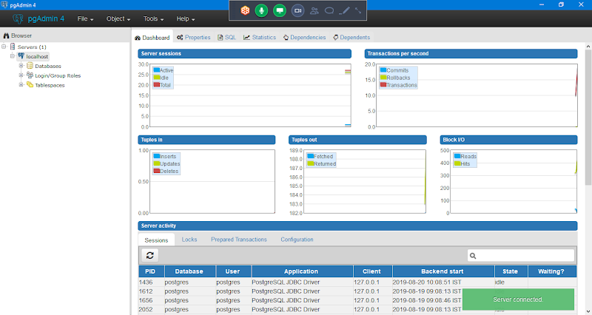

**Right Click on databases to add new data base connection:**

**Right Click on databases-> Create-> Database**

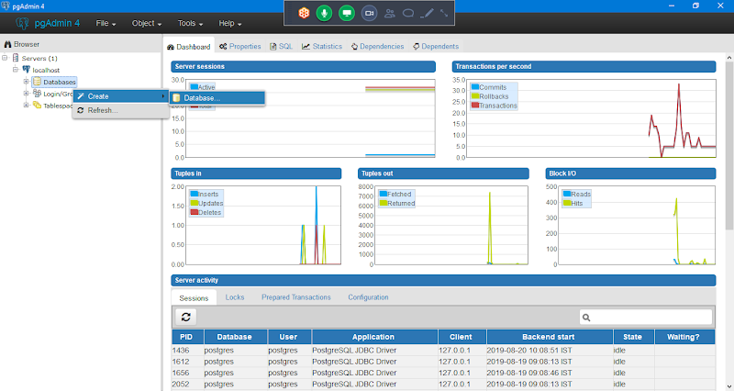

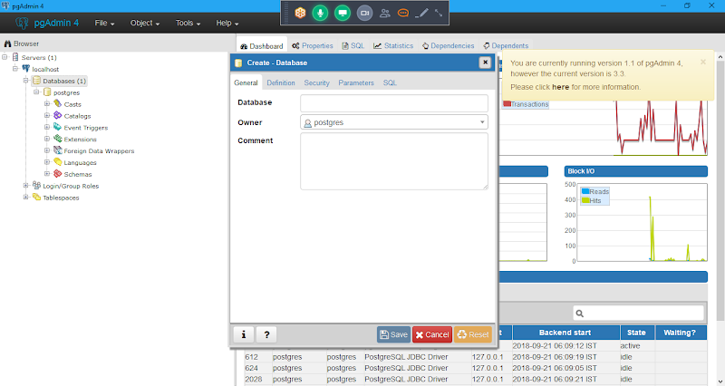

**Give database name**

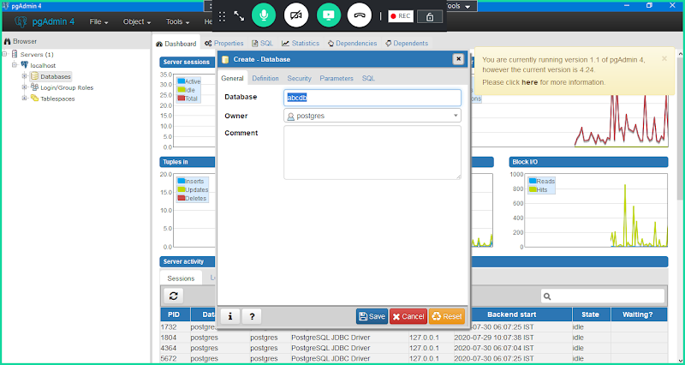

**Go to Security tab:**

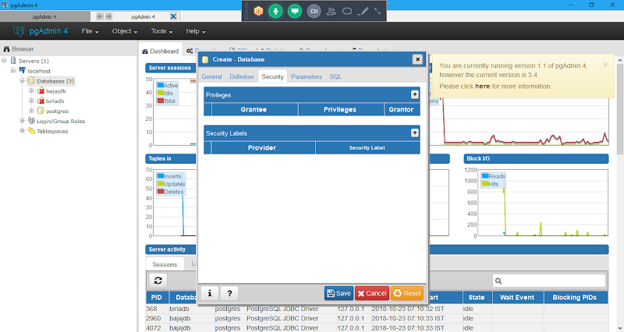

**Click on Add under Privileges**

**Under Grantee Tab: Select public**

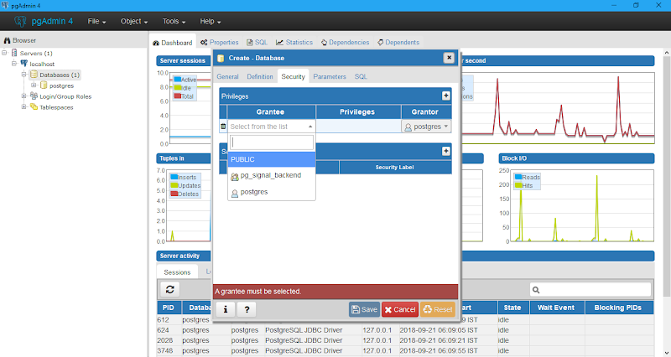

**In Dropdown Select public**

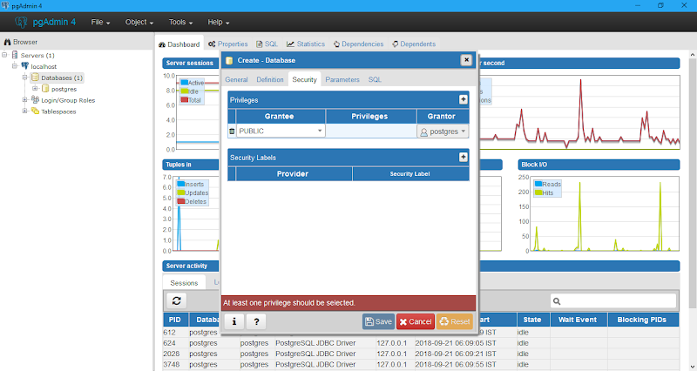

**Click on Privileges**

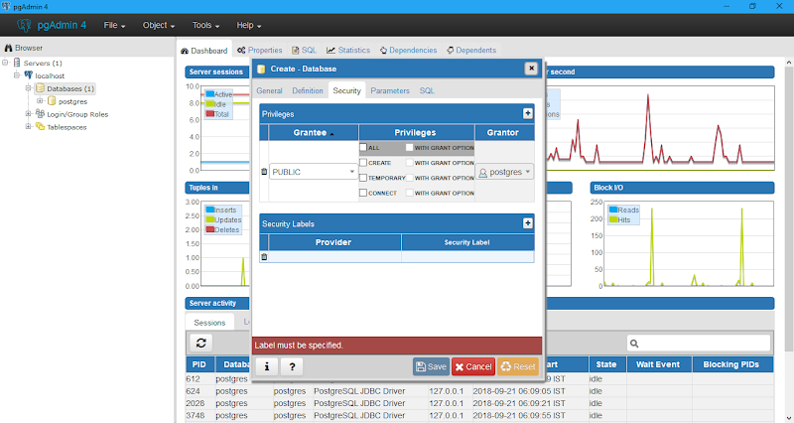

**Select All**

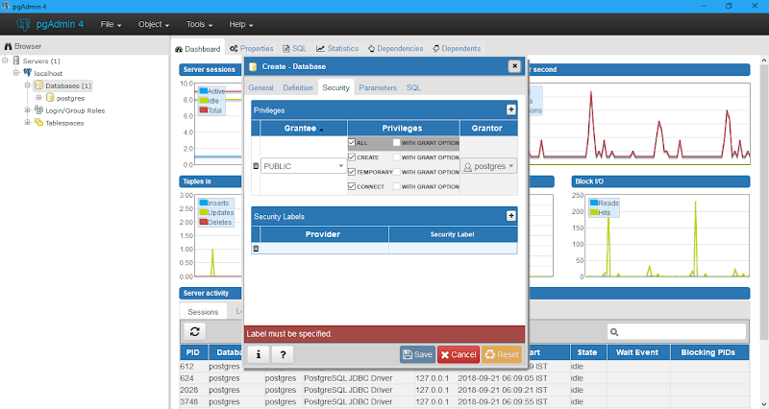

**Click any where outside the window, then privilege is added ( CTc)**

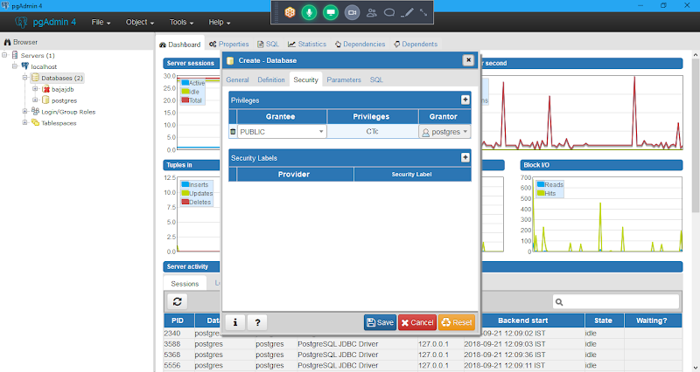

**Click on Save**

**Now We Can See Data Base Name Under Data bases ( abcdb)**

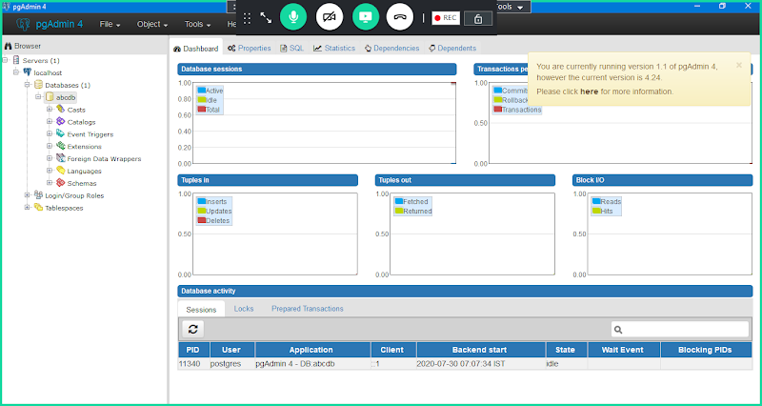

**Click on Database name, then it will be connected**

**DB got Created.**

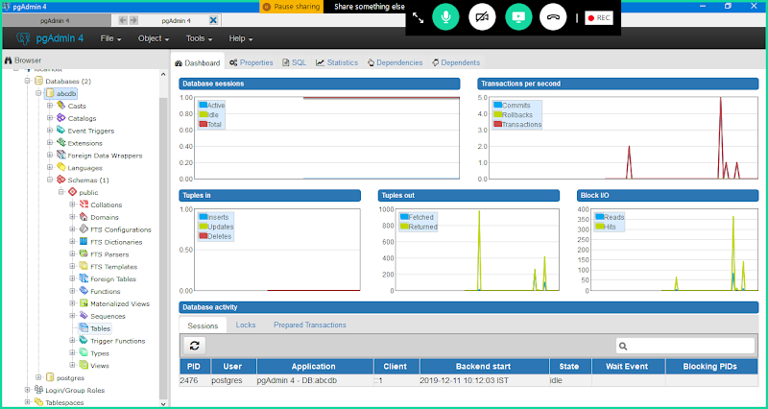

**2. Create Physical table along with columns & Add Required privileges**

**Add table under abcdb**

**Expand Data Base-> abcdb -> Schemas-> public-> tables**

**From Tables -> Add a New Table**

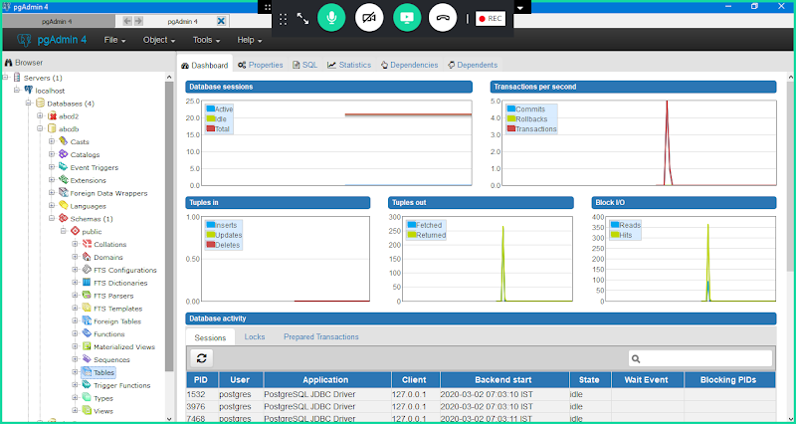

**Add A New Table:**

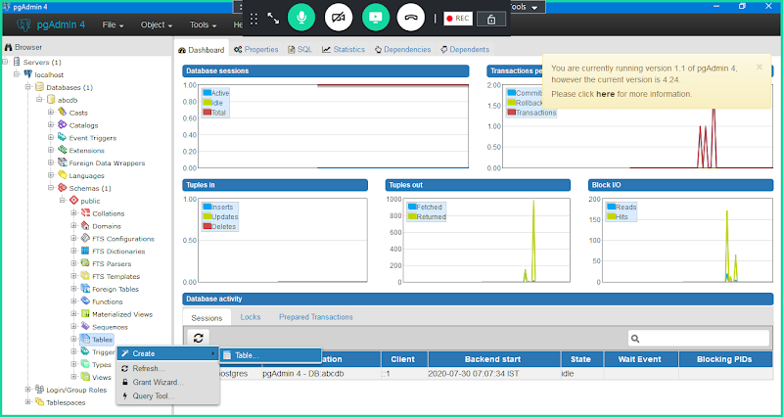

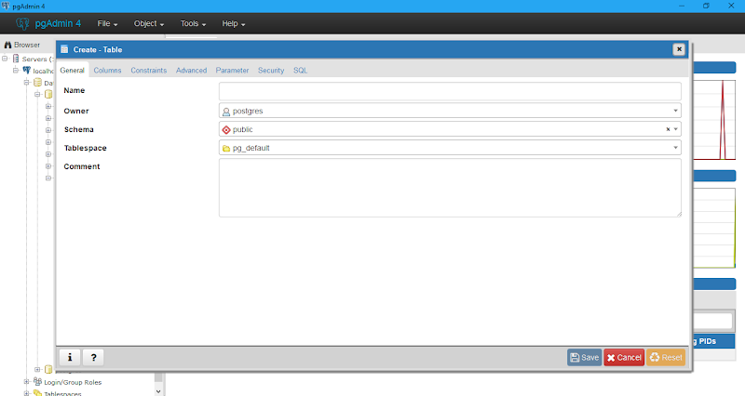

**Table Name: custtable**

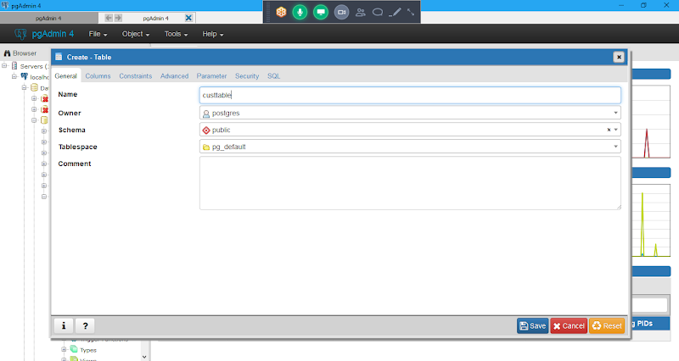

**Go to Columns Tab:**

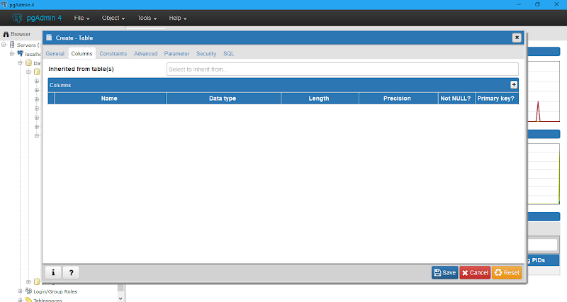

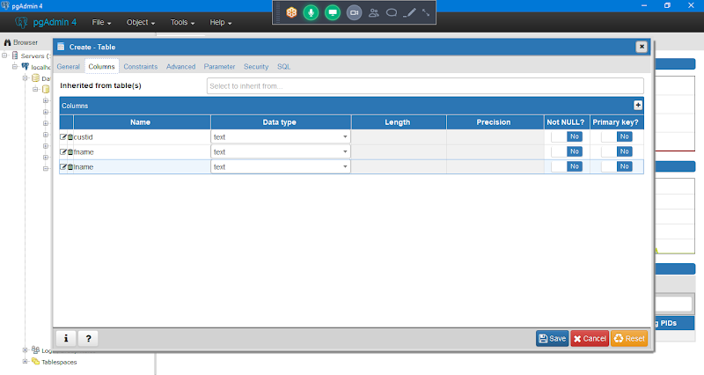

**Set Primary Key from Columns Tab:**

**Enable Yes for CustID Property under primary key.**

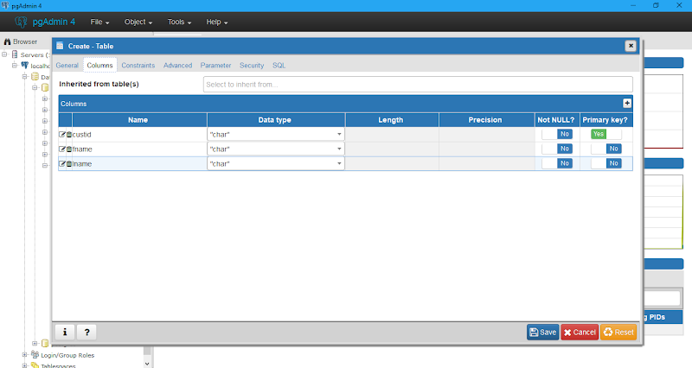

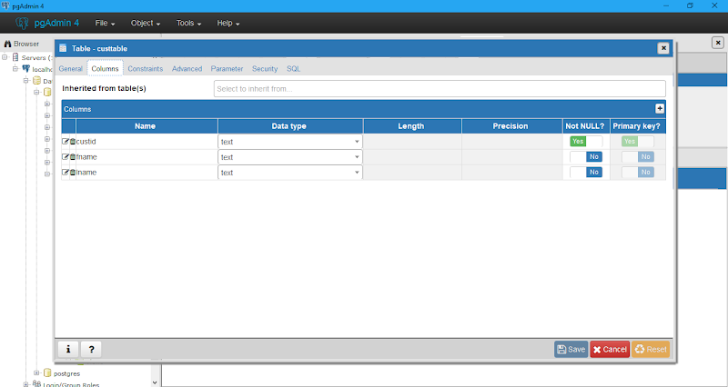

**Go to Constraints Tab to Verify Primary key is custid or not**

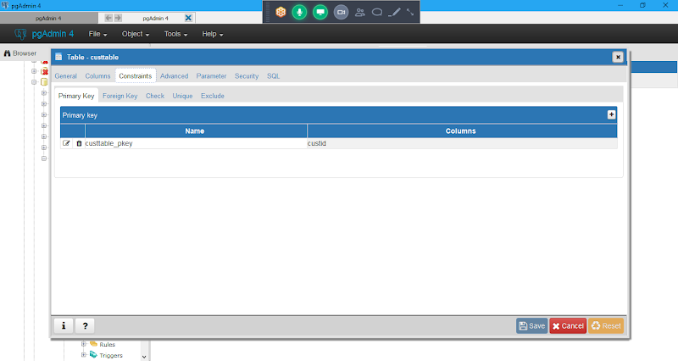

**Go to Security tab:**

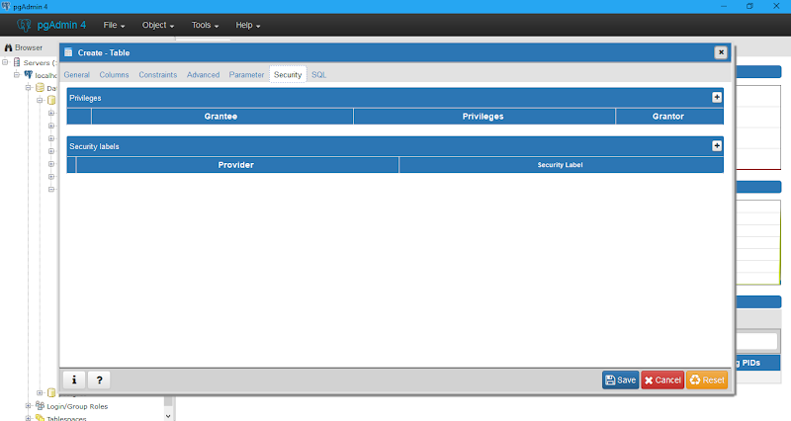

**Click on Add**

**In Grantee Select : Public**

**In Privileges Select All Check box**

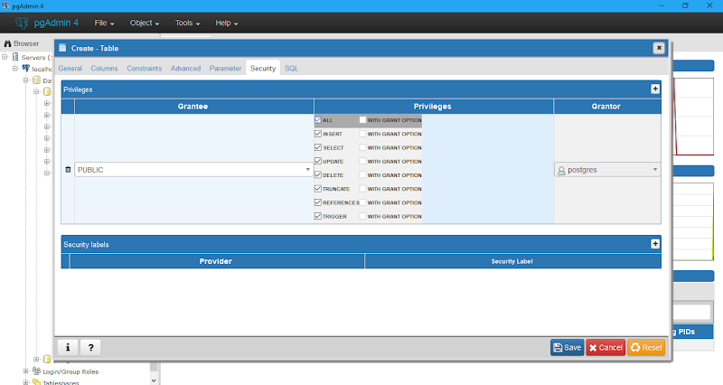

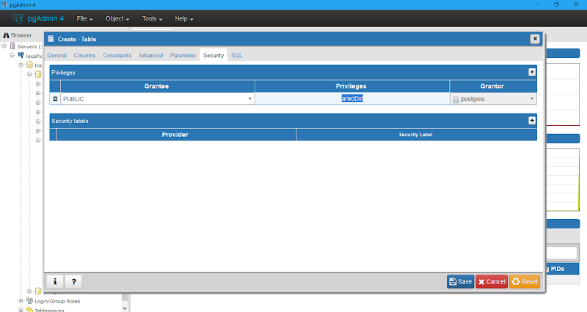

**Click on Save**

**custtable is Created.**

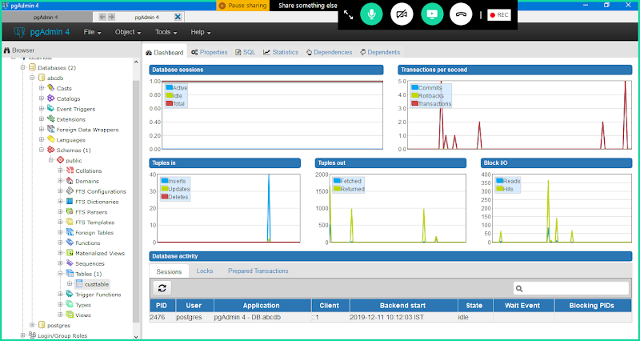

**Now Open Table: Right Click on Table-> View Data -> View All Rows**

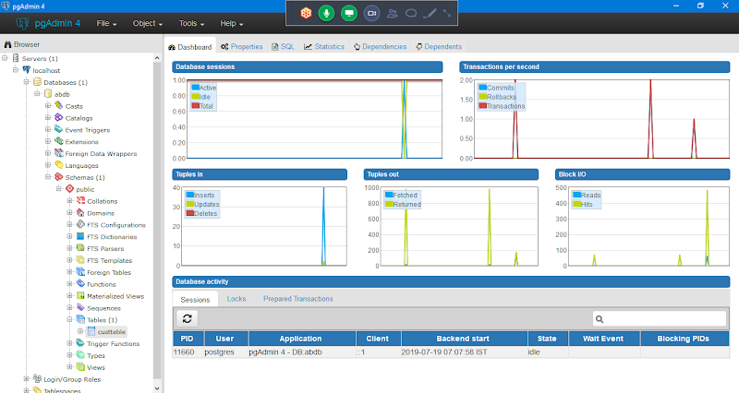

**Manually Add Records to table:**

**Right Click on Table-> View Data-> View All rows**

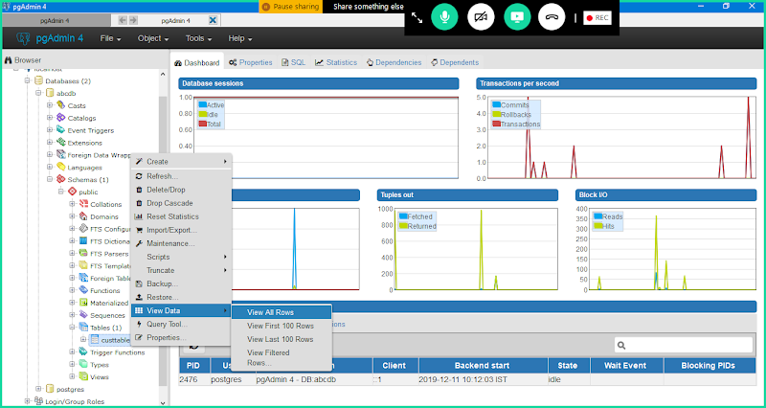

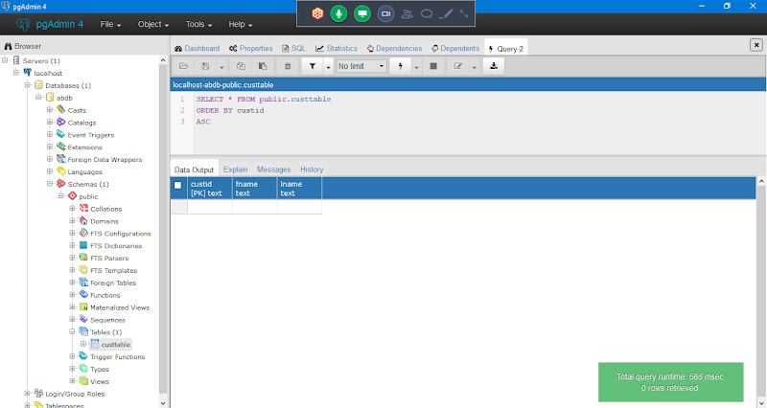

**Manually add Records**

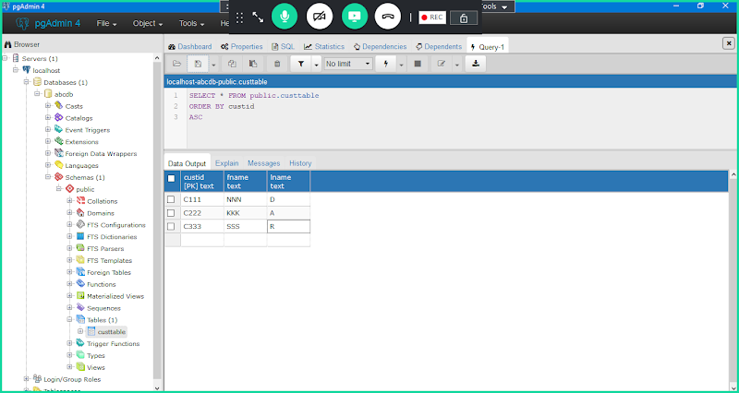

**=======**

**3. Make Connection b/w PRPC & Data base by creating a rule type Database. Create Under Work Layer:**

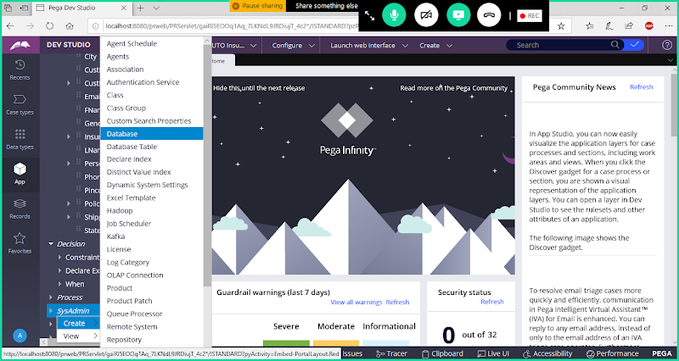

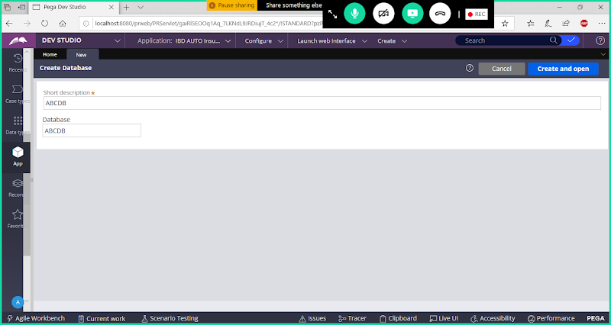

**Open**

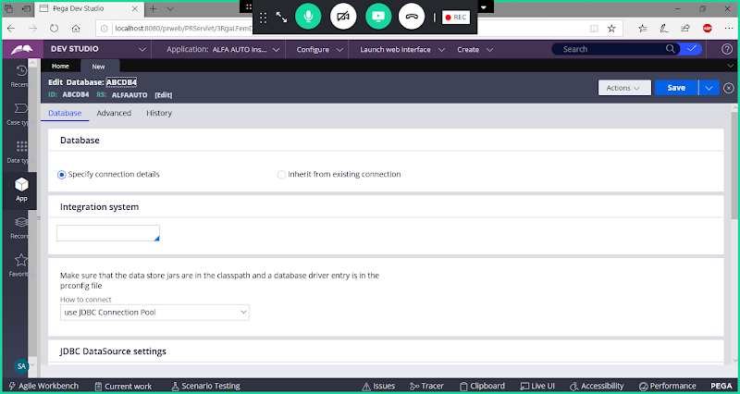

**Select : JDBC Url Listed below**

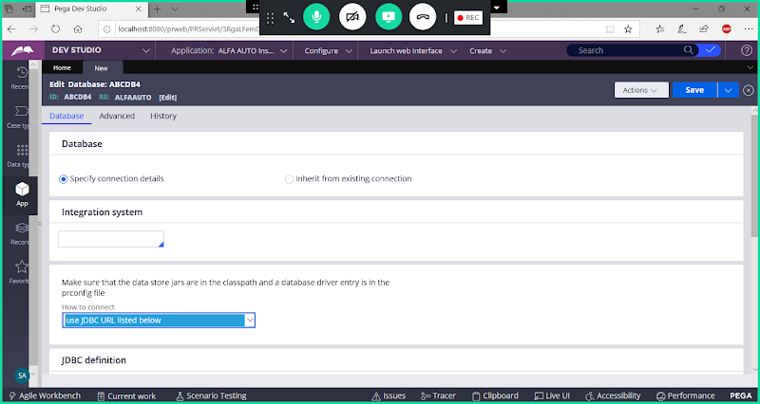

**jdbc:postgresql://localhost:5432/DatabaseName**

**or**

**jdbc:postgresql://localhost:5434/Database Name**

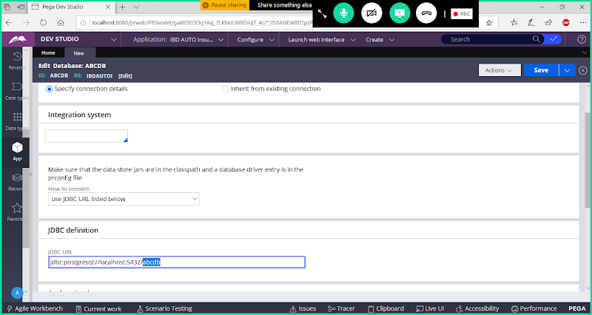

**Provide UserName & Password as postgres**

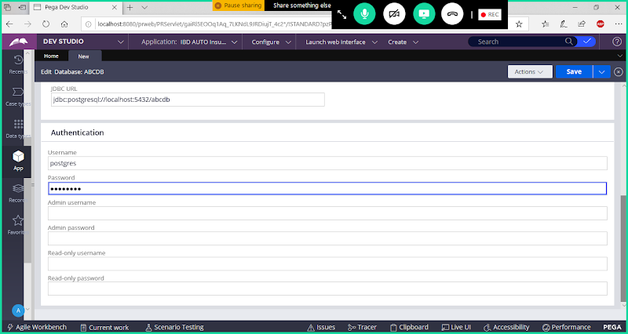

**Save Data Base Rule.**

**For JDBC Url:  PRPC PersonalEdition Folder-> tomcat-> Conf-> Context.xml**

**open File**

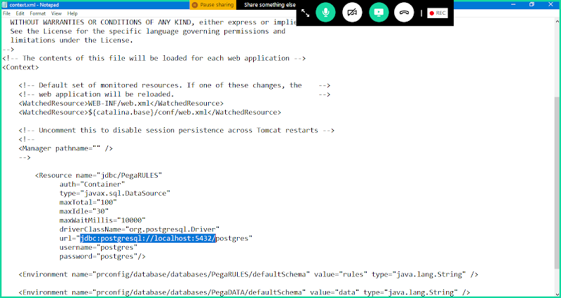

**Username: postgres**

**Password: postgres**

**Now Click on test Connection**

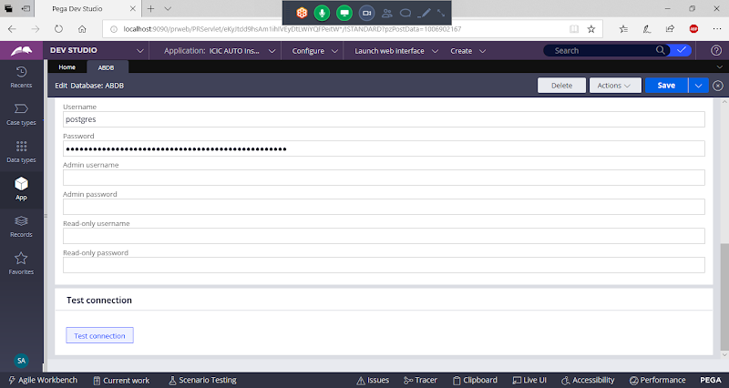

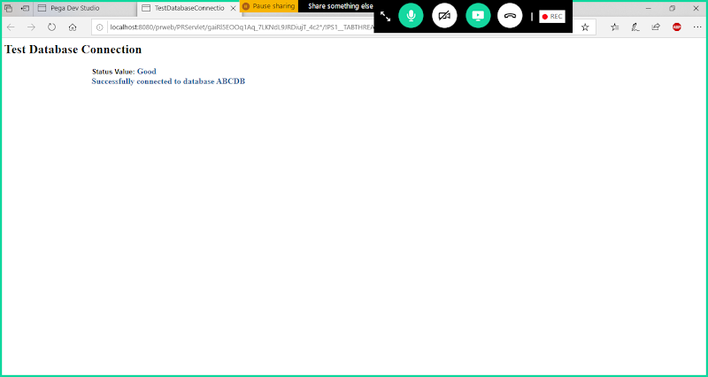

**4. Create a Data Dype & Properties to map to above table**

**Add Data Type: CTable**

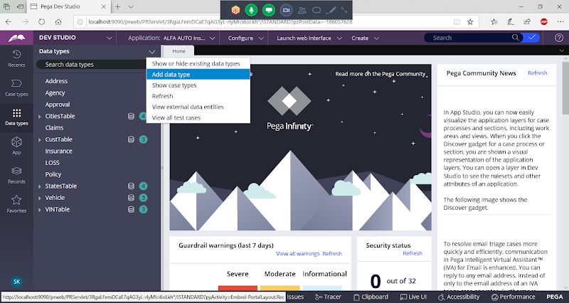

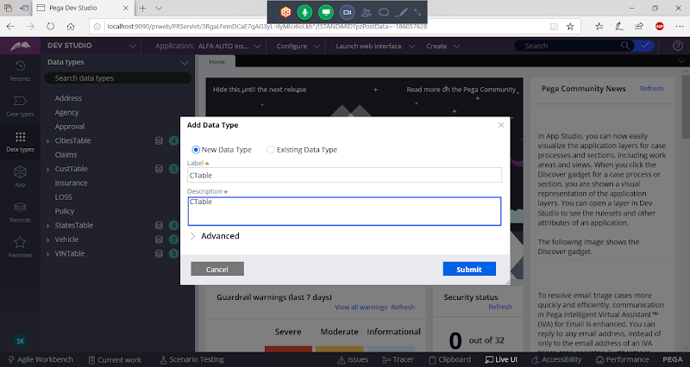

**Click on Submit**

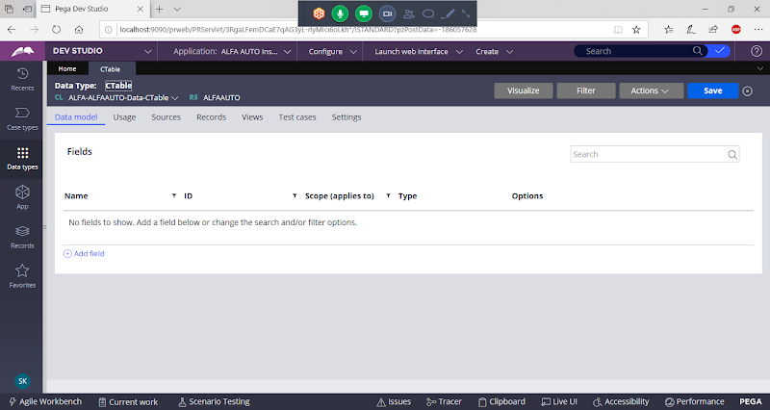

**Add Properties Using Data Model Property Wizard.**

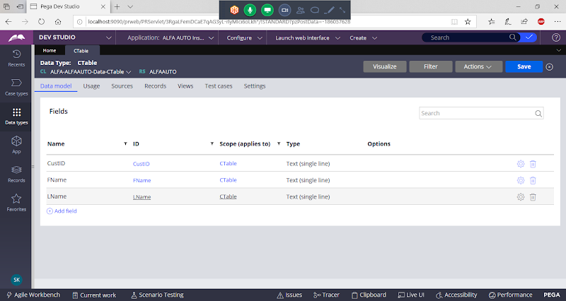

**Set Class Key from CustID Property**

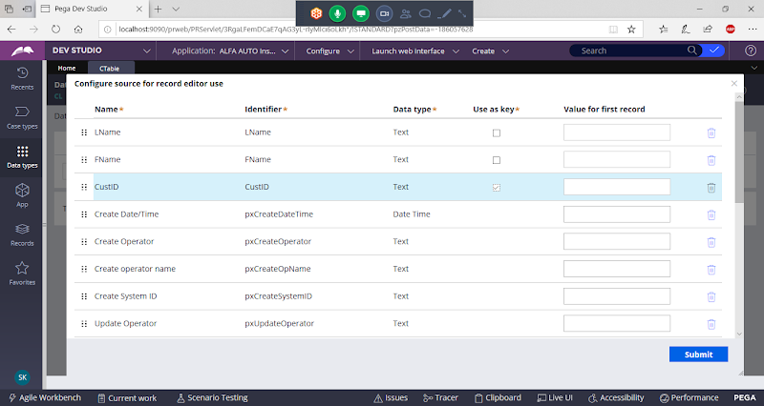

**Submit & Close.**

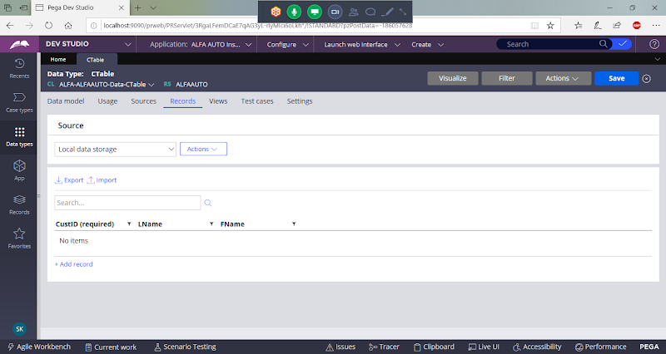

**5. For Data Class & Table mapping create a ruletype called database table**

**Create Data base Table rule under Work Class group:**

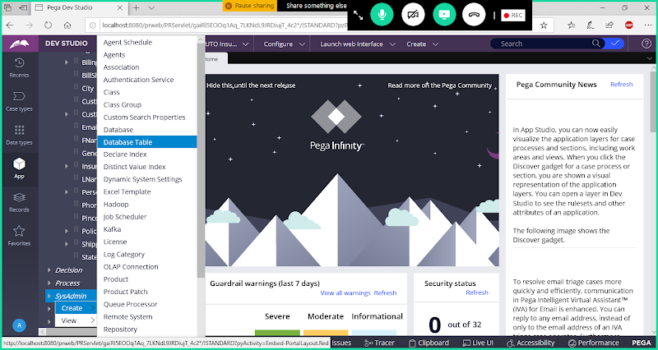

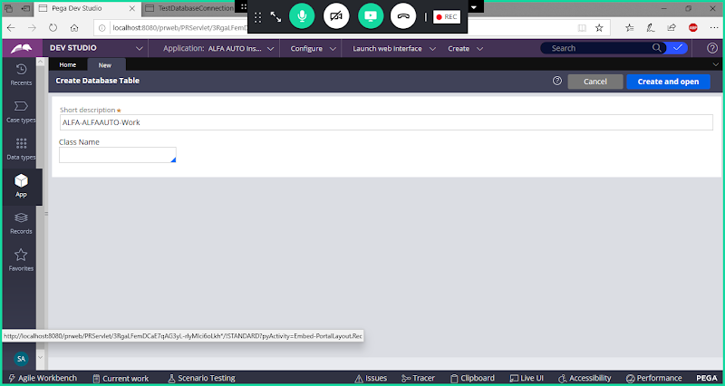

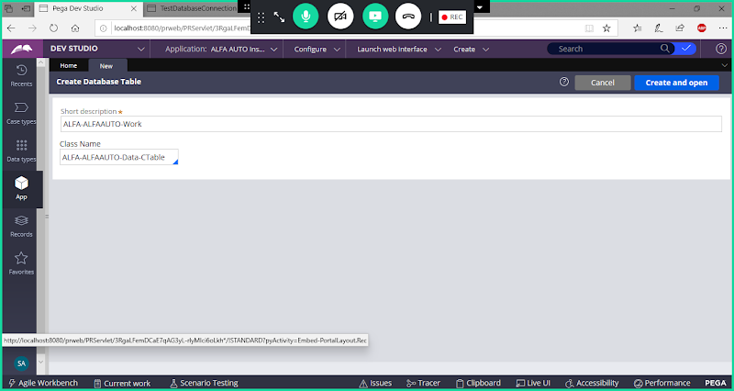

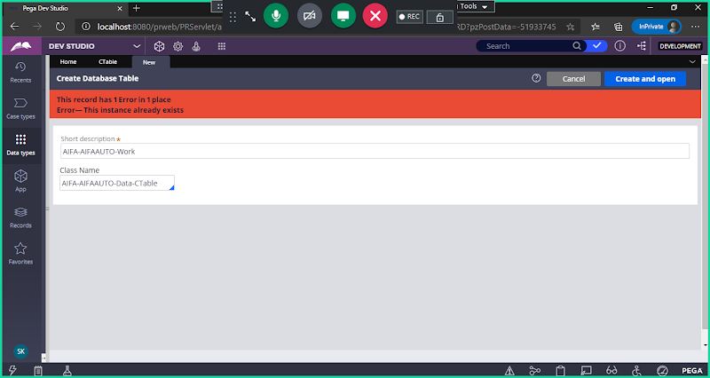

**( If getting any error while opening the rule, then open rule from Records exp-> Sysadmin->database table->  open ur Data base table)**

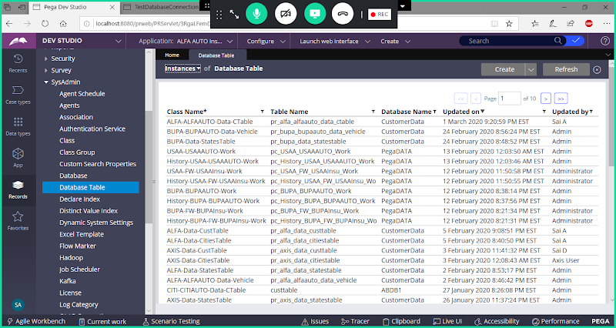

**Open Customer Data Base Table.**

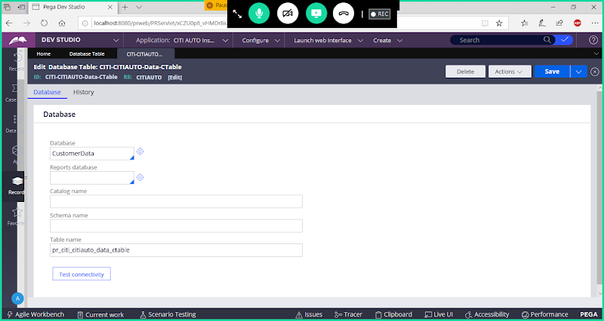

**Update Data base Name & Table Name:**

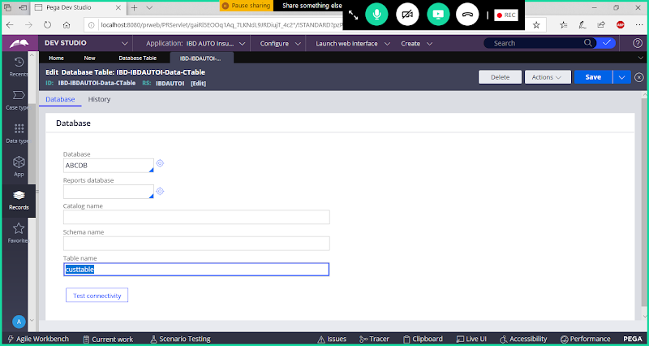

**Save & Click on test connectivity**

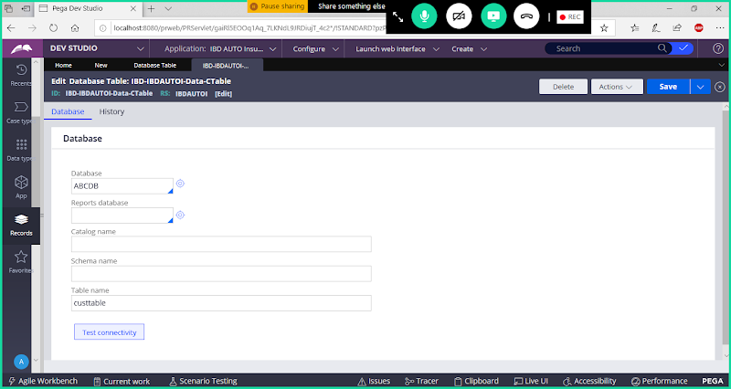

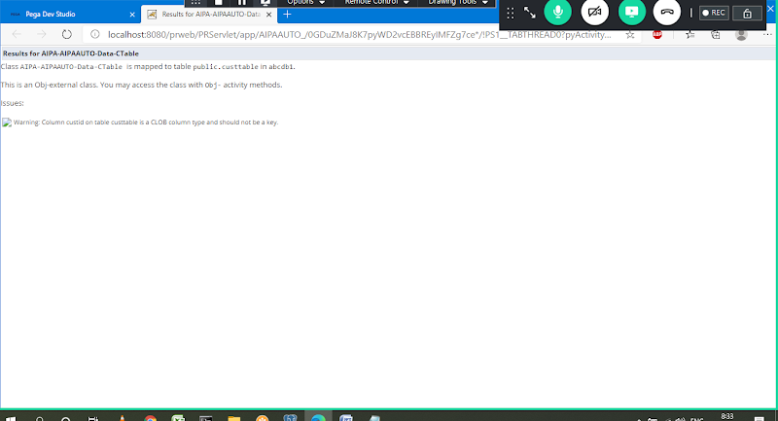

**6. Create a Connect SQL Rule & write required statements**

**Create connect-sql under Ctable data class:**

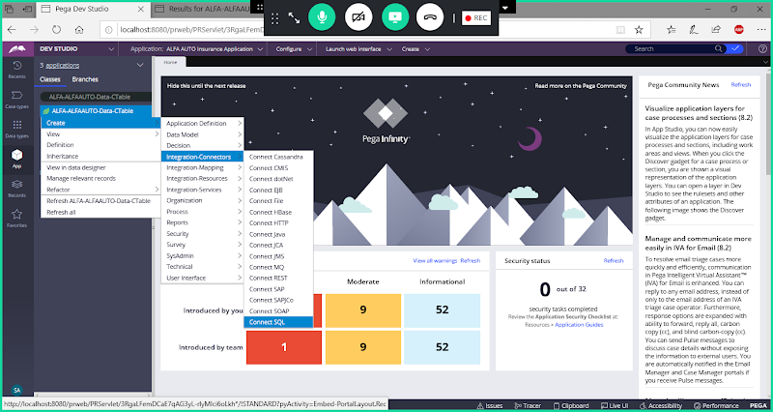

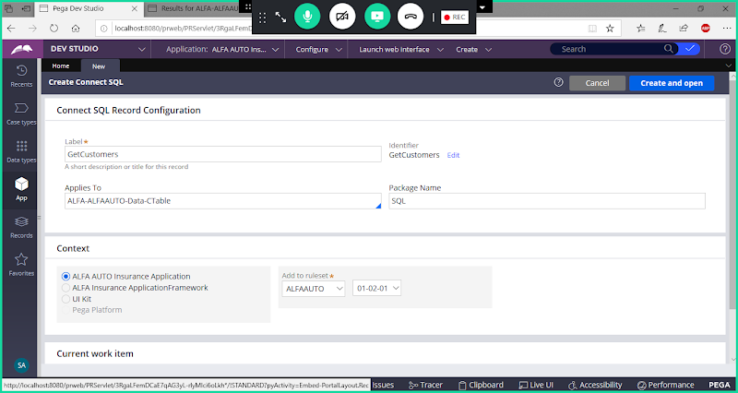

**Open**

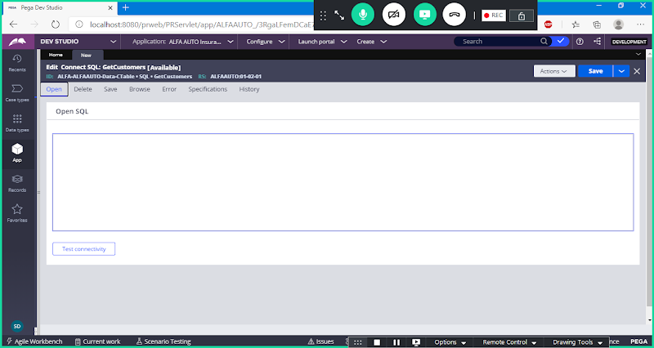

**Open- Fetch Single Record**

**Delete: To delete records**

**Save: To insert/Update the Records**

**Browse: Fetch Multiple Records**

**Open**

**Go to Browse tab to add query:**

**Select * From {Class:** **ALFA-ALFAAUTO-Data-CTable};**

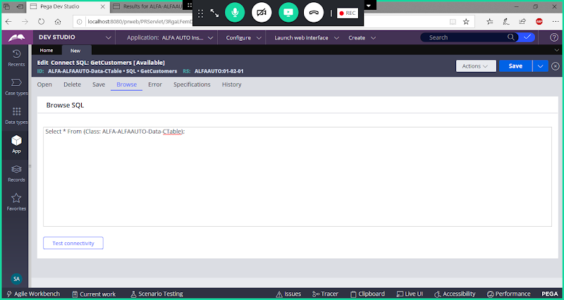

**Go to Open Tab:**

**Select * From {Class:** **ALFA-ALFAAUTO-Data-CTable};**

**where custid='C1'**

**Save  Connect SQL:**

**7. Create an Activity & Use RDB Methods to Execute above queries**

**Create activity under work class:**

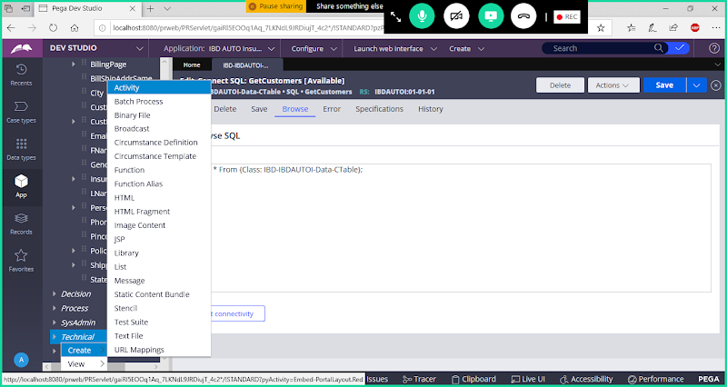

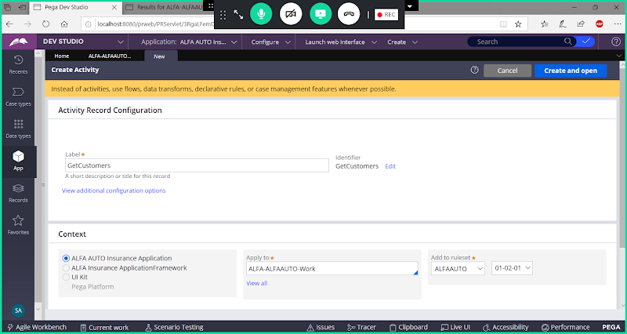

**RDB Methods: To Read the queries from Connect SQL we will use RDB  Methods**

**RDB-open**

**RDB-save**

**RDB-list : Fetch multiple records**

**RDB-delete**

**Go to Steps Tab:**

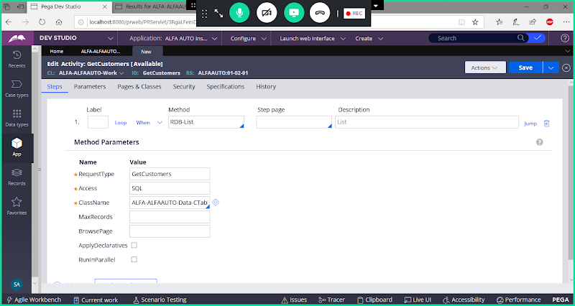

**Give Browse page name:**

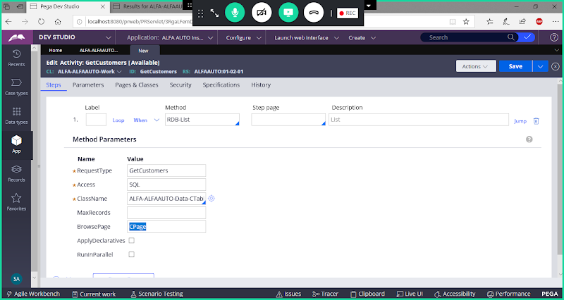

**Save & Run Activity & Debug using Clipboard**

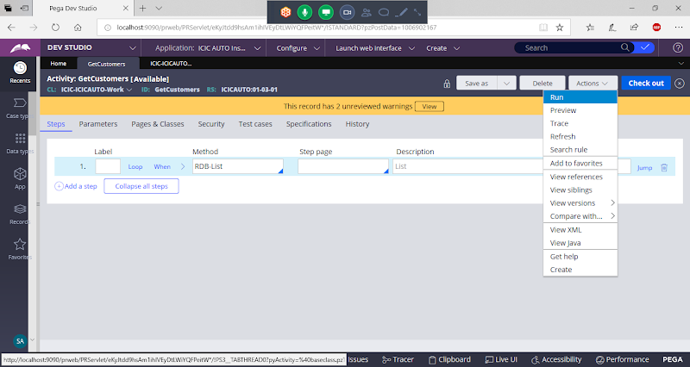

**Open Clipboard & check the results:**

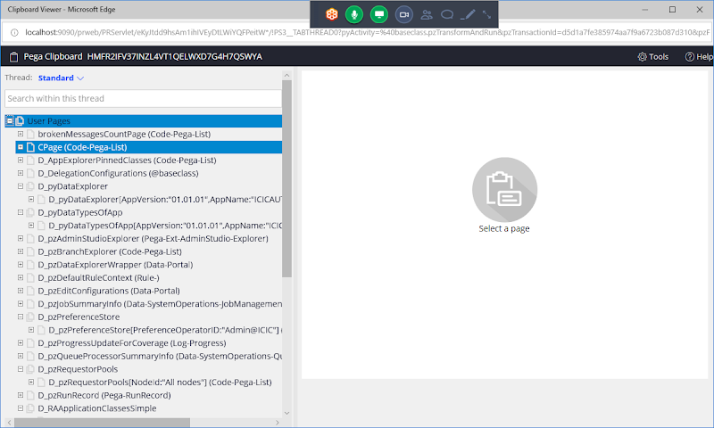

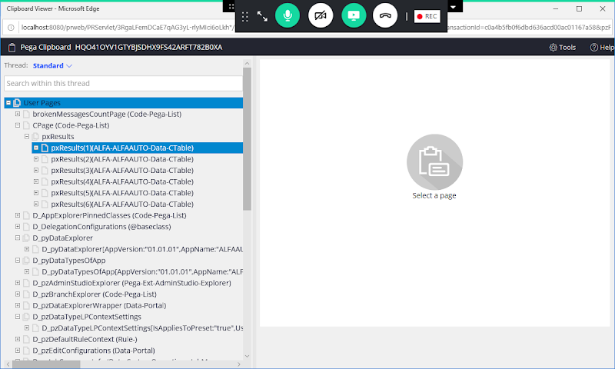

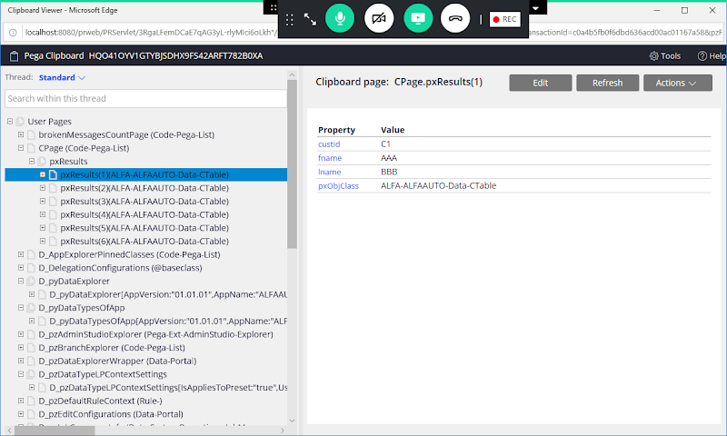

**Diff b/w RDB & OBJ methods:**

**RDB        -                   OBJ**

**Execute Connect SQL  queries      -     Generates Own queries**

**External DB                           -     Internal DB**

**Cannot browse data from BLOB  -  Can Browse**

**Browse only from exposed columns   -  Can Browse from Exposed & Non Exposed columns**

**Commit is Required                 - Commit is not required**

**Processing faster               -   Slower**

**RDB Open: No Locking         -   Obj-open: Locking is Built in**

**Design lock tables by own code**

**Stored Procedures is possible   - We cannot execute stored procedures**

**What is Stored Procedures?**

**Stored Procedure is a set of sql statements with an assigned name, which are stored in a RDBMS as a group, so it can be reused and shared by multiple programs.**

**How to call Stored procedures:**

**Browse Tab:**

**Exec Procedure  / Call Procedure**

**===================**